SENSITIVITY ANALYSIS FOR UPPER.EAST4 REGION – GHANA
EIR AS A PREDICTOR IN BOTH TRAINING AND PREDICTION
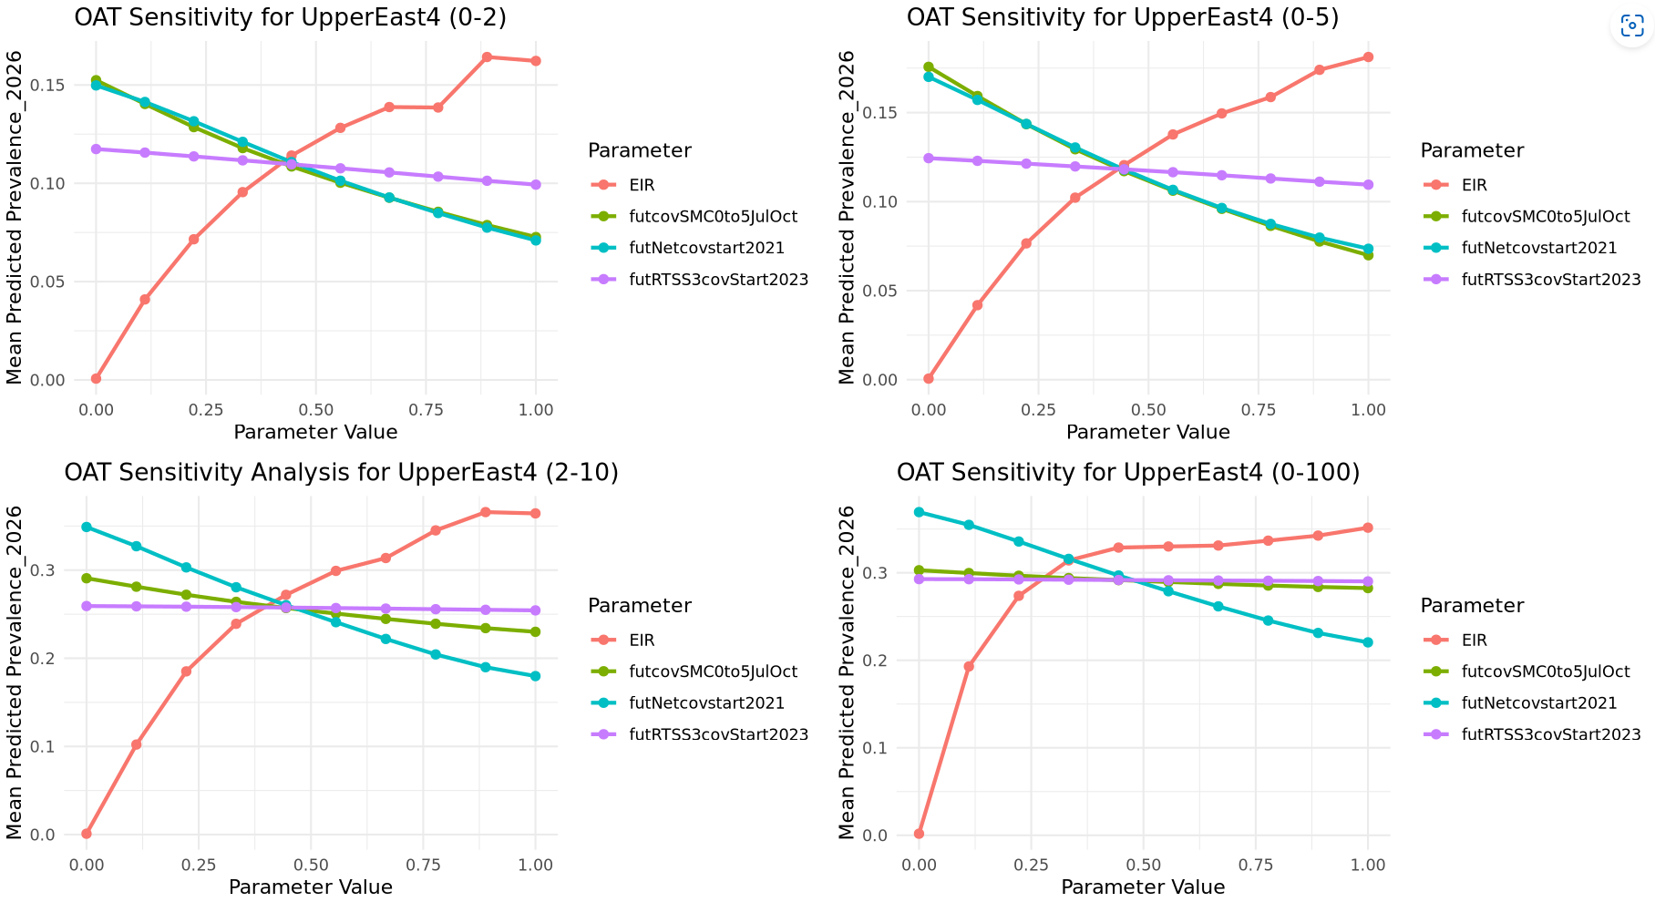

SOBOL
- FULL EIR RANGE FOR TRAINING AND PREDICTION (LHS SAMPLING OF X1 AND X2 IN SOBOLSALT)
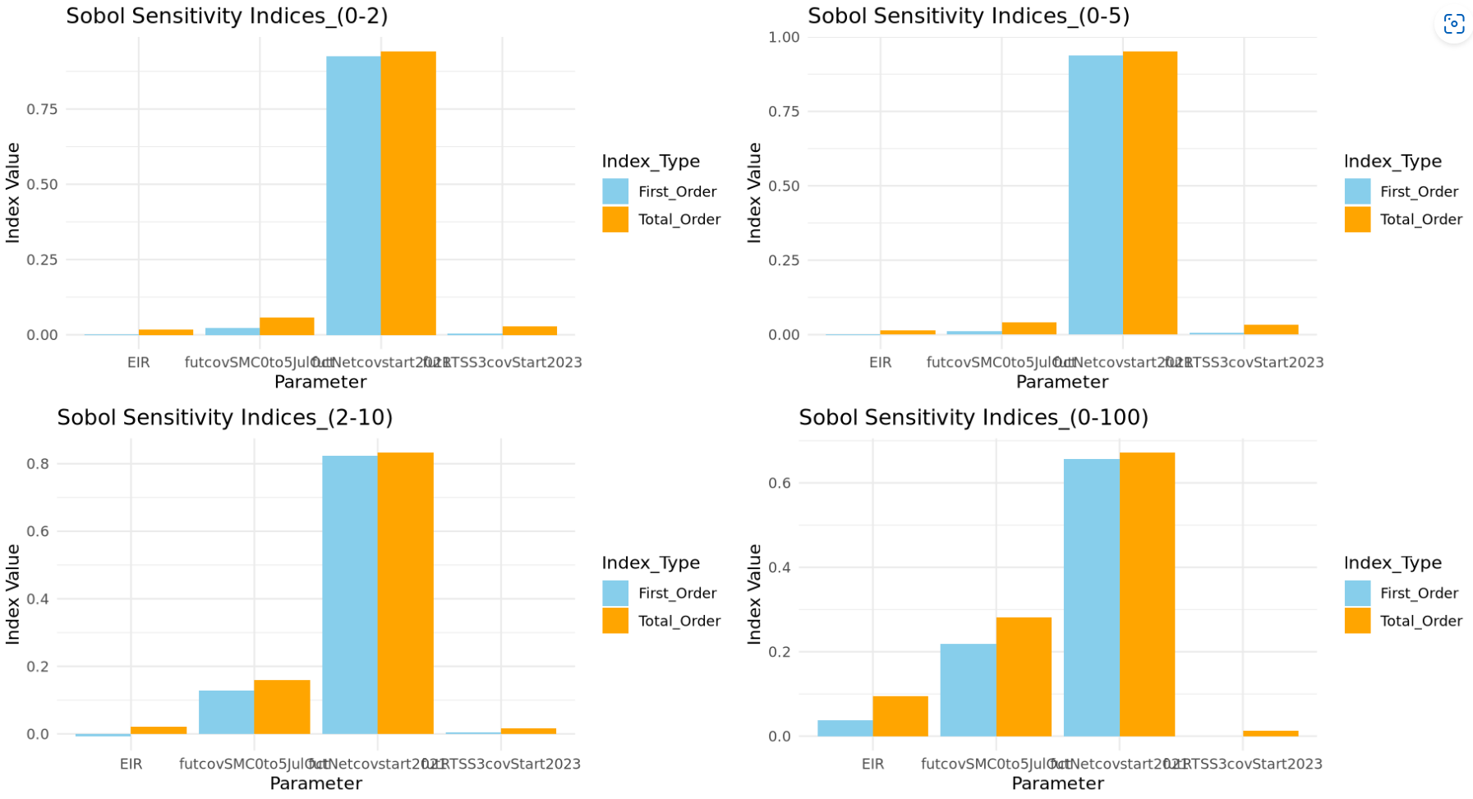
NB: Properties of Sobol sensitivity indices (for the interpretation of the results)
- STi is greater than Si, or equal to Si in the case that Xi is not involved in any interaction with other input factors.
- STi − Si is a measure of how much parameter Xi is involved in interactions with any other input parameter
- STi = 0 implies that Xi is noninfluential and can be fixed anywhere in its distribution without affecting the variance of the output
- The sum of all Si is equal to 1 for additive models and less than 1 for nonadditive models.
- The difference 1 − ∑Si is an indicator of the presence of interactions in the model.
- The sum of all STi s is always greater than 1. It is equal to 1 if the model is perfectly additive.

- FIRST ORDER AND INTERACTION EFFECTS PLOT
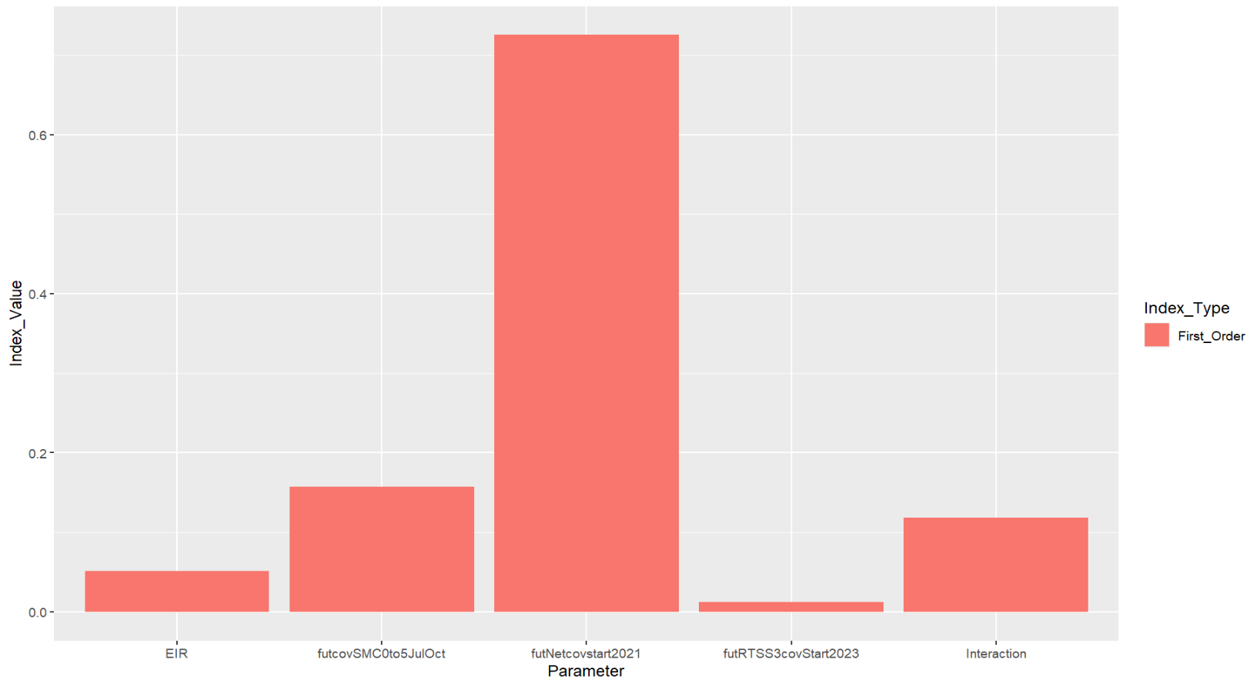
NB: Si indicates by how much one could reduce, on average, the output variance if Xi could be fixed.
The output variance (uncertainty in prevalenceRate) could be reduced by over 50%, on average, if futNetcov could be estimated.
Actual vs predict for 3 settings: full EIR sweep for UE and LHS for Oti and BE – Training the Gp with all simulation data

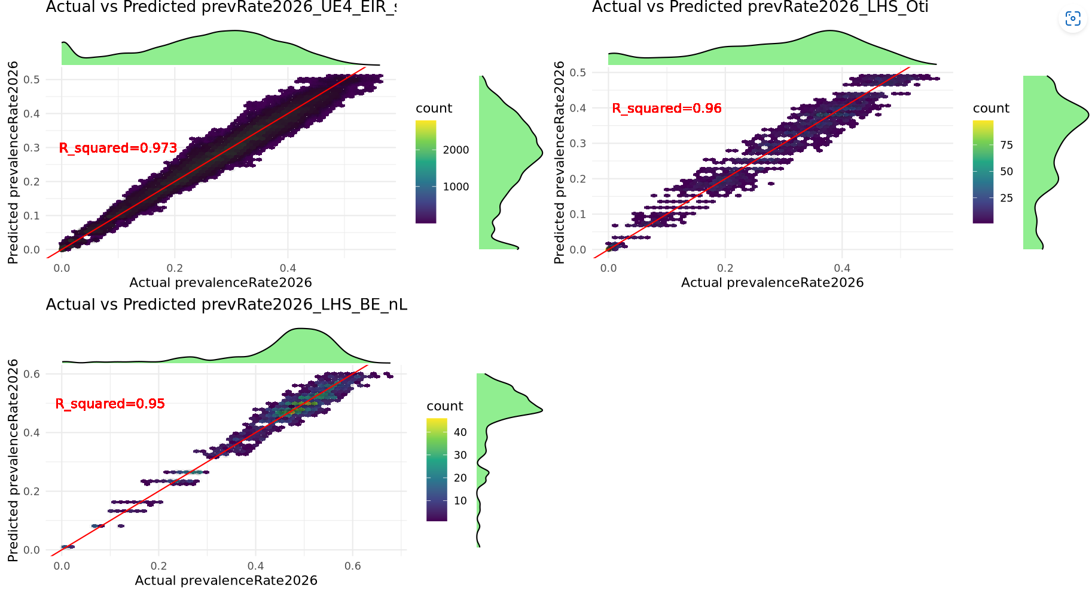

ZOOM INTO THE 0-2 PREV WINDOW (UE, OTI and BE)
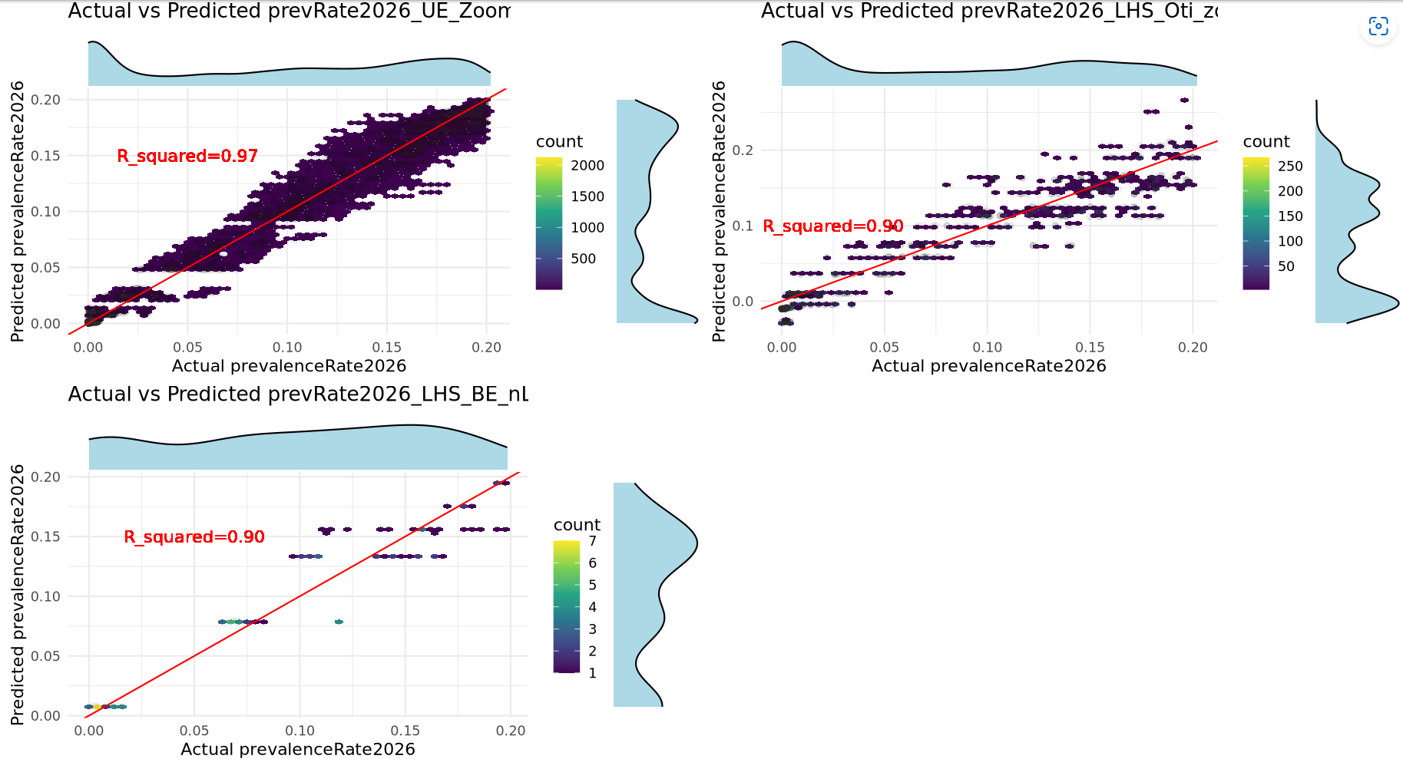

Actual vs predicted for UE4 (LHS) and UE4 (Sweep)
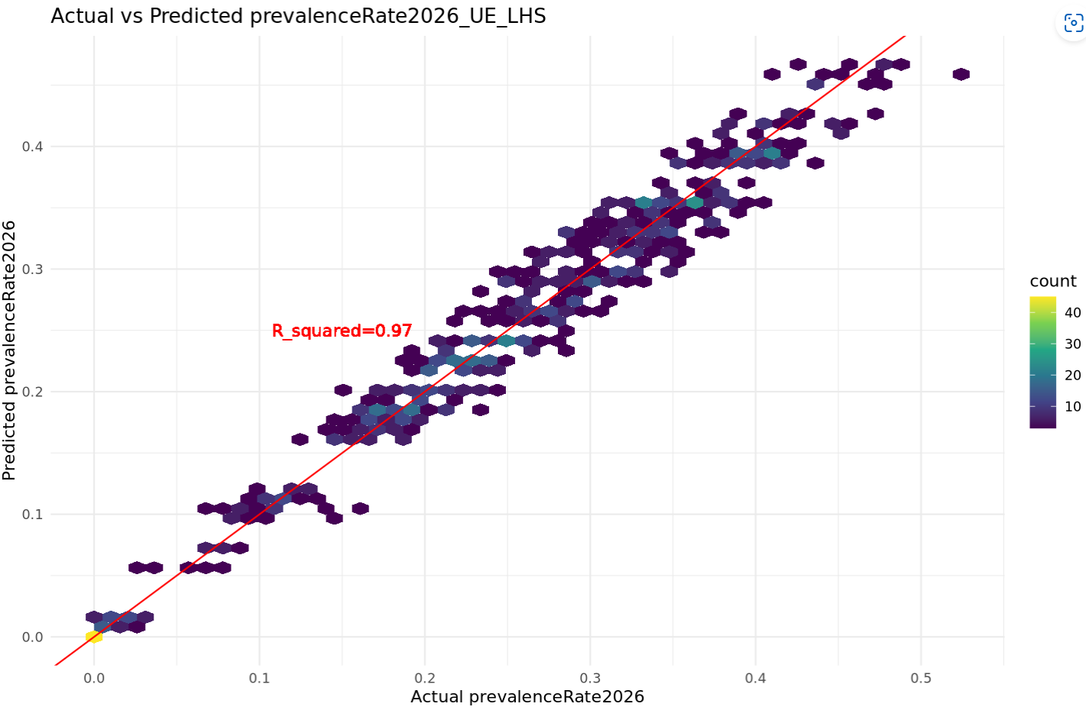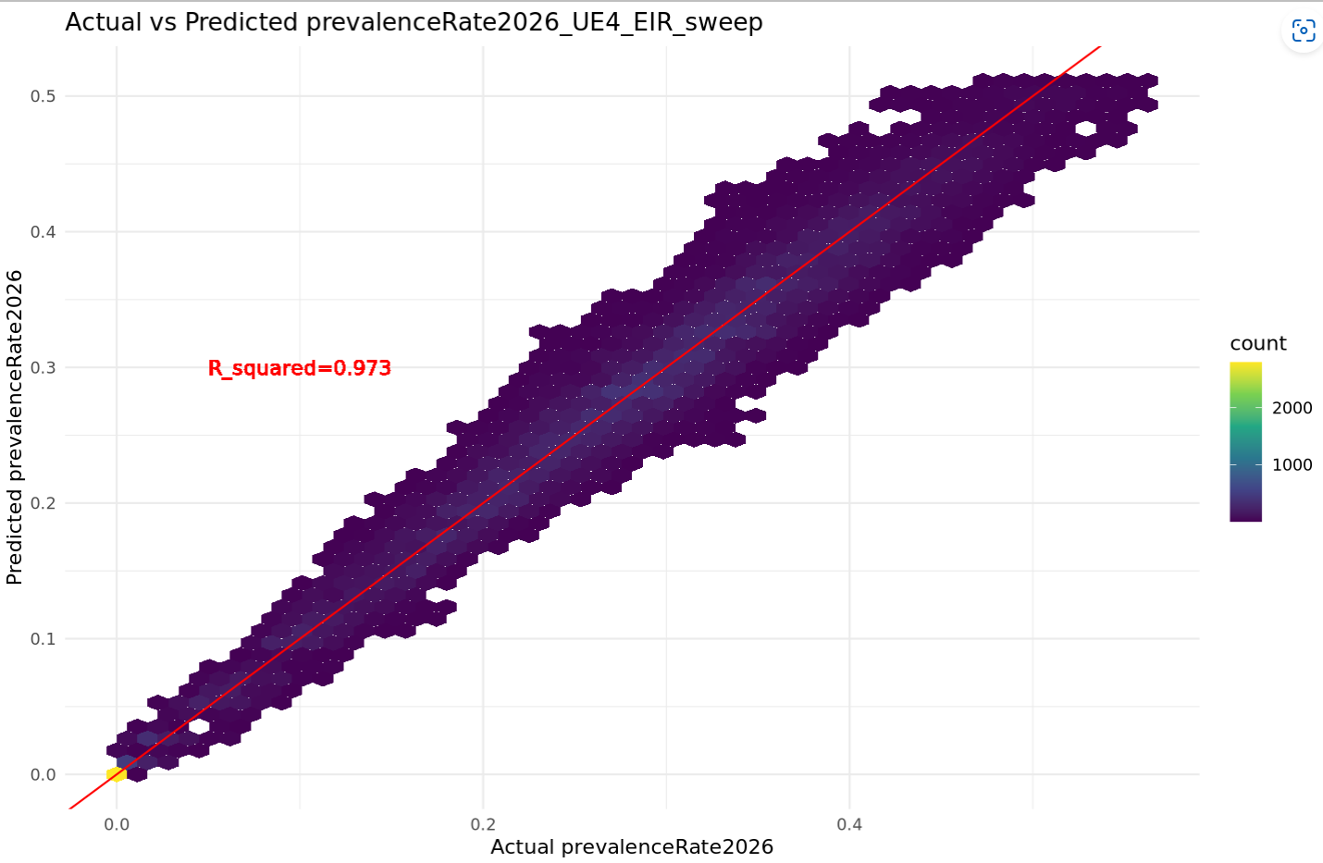

TABLE
Y_COL = prevalenceRate_2026, AGE_GROUP = 2-10
SETTING | NUMBER OF SIMULATIONS REQUIRED (SWEEPS) | NUMBER OF SIMULATIONS REQUIRED (LHS) | R-SQUARED | NUMBER OF X_COLS | GP TRAINING TIME (mins)
UPPER.EAST4 | 6000 / 50K | 1500 | 0.97 | 4 | 11.9 / (LHS)
OTI | 300000 | 2500 | 0.96 | 4 | 1.9
BONO.EAST (no_LSM) | 212500 | 2000 | 0.95 | 4 | 1.4
Sweep: create a sequence of the param range and merge

Y_COL = PrevalenceReduction, AGE_GROUP = 2-10
SETTING | R-SQUARED | GP TRAINING TIME | Sobol Indices Cal time (mins)
UPPER.EAST4_sweep | 0.47 | 30.5 mins
OTI
BONO.EAST (no_LSM)
UPPER.EAST4_LHS | 0.26 | 6.1 secs

Actual vs Predicted for prevReduction (dividing by Max prev2023 or 2026) – sweep (left) and LHS (% prev reduction - right)
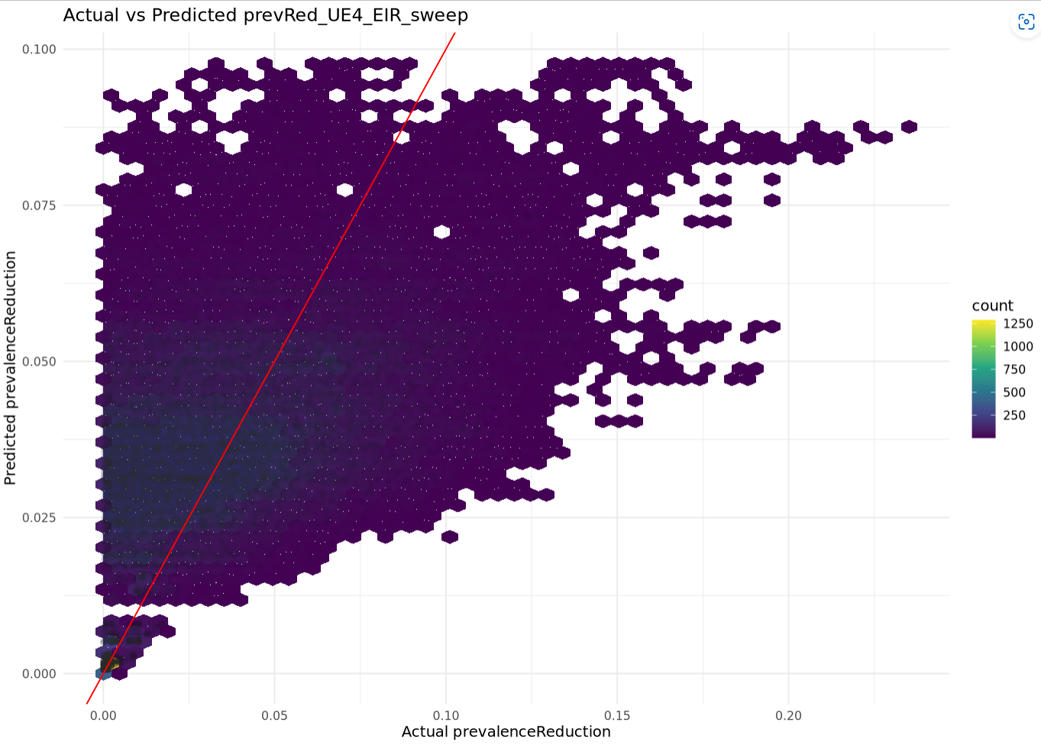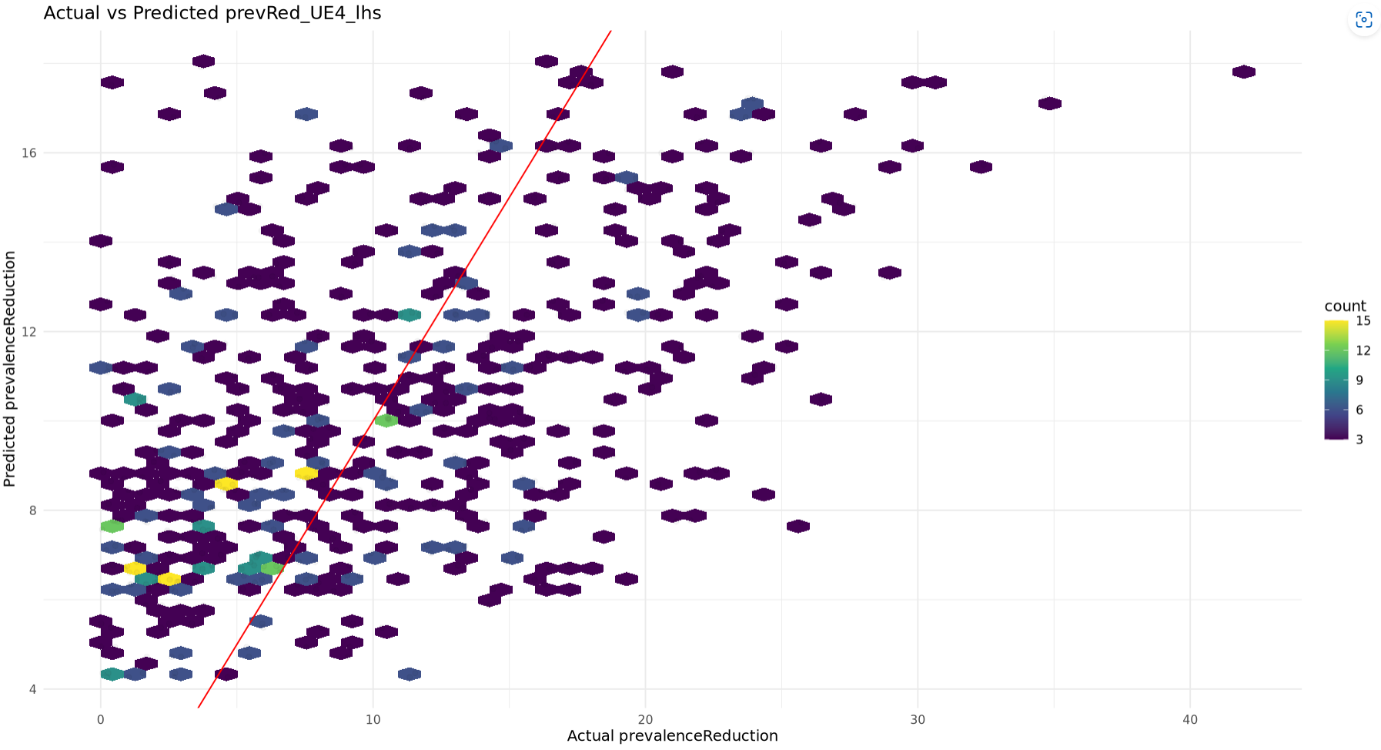
ACT VS PRED From 2 different models
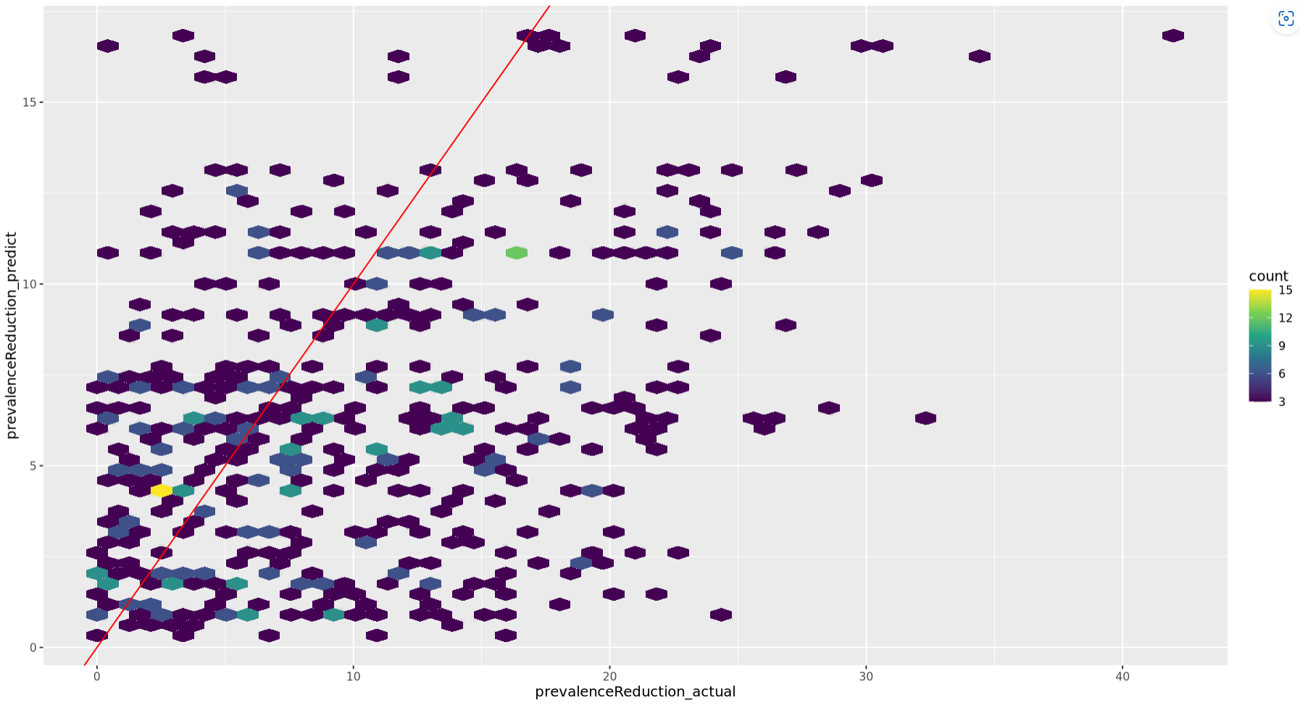
SOBOLJANSEN SENSITIVITY PLOTS
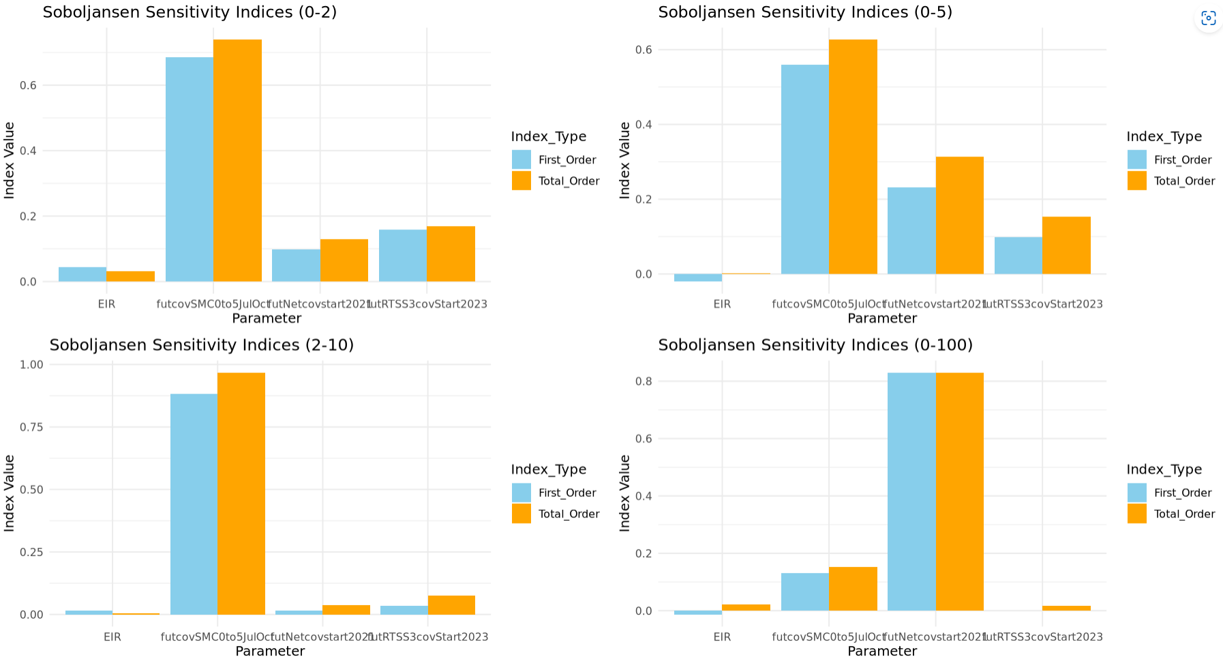
NB: EIR is not in the right order for all age groups

SOBOLJANSEN SOBOLSALT
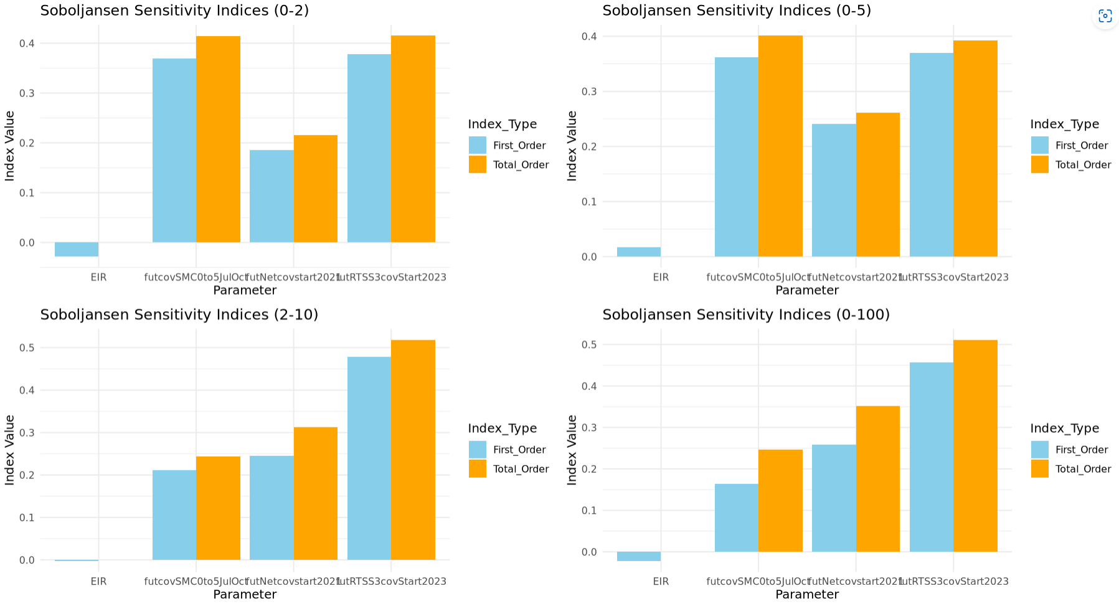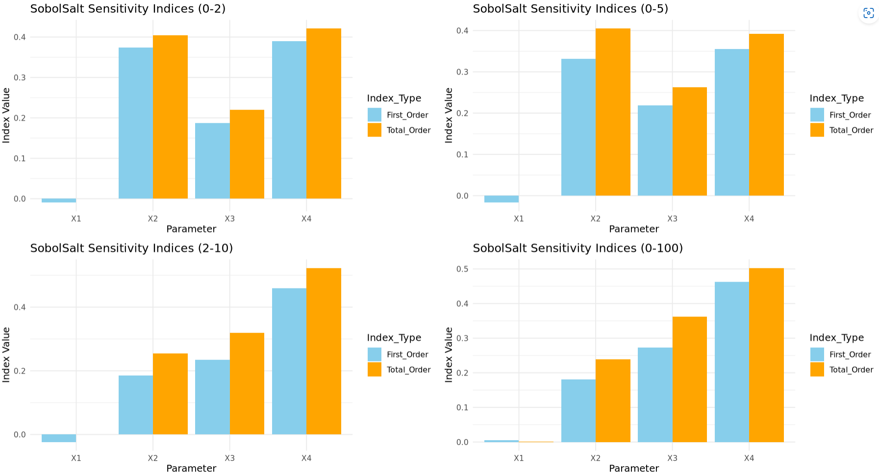

SOBOLJANSEN OTI
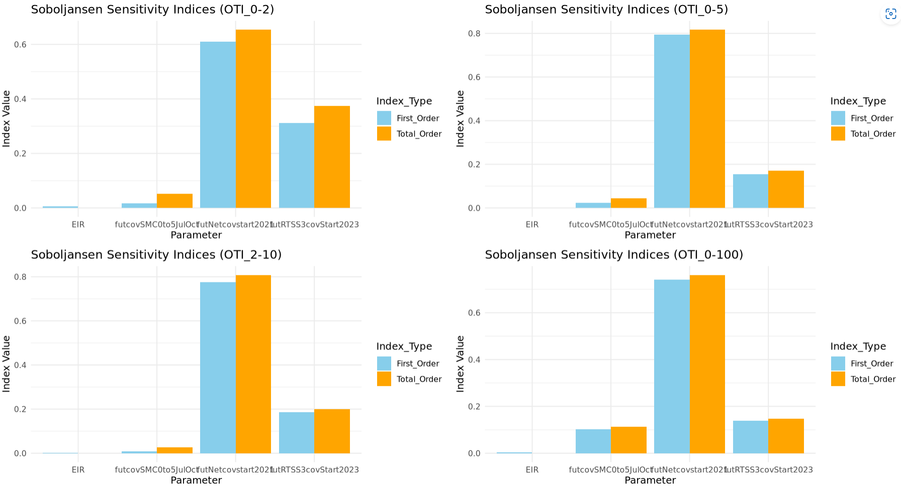

SOBOLJANSEN UE
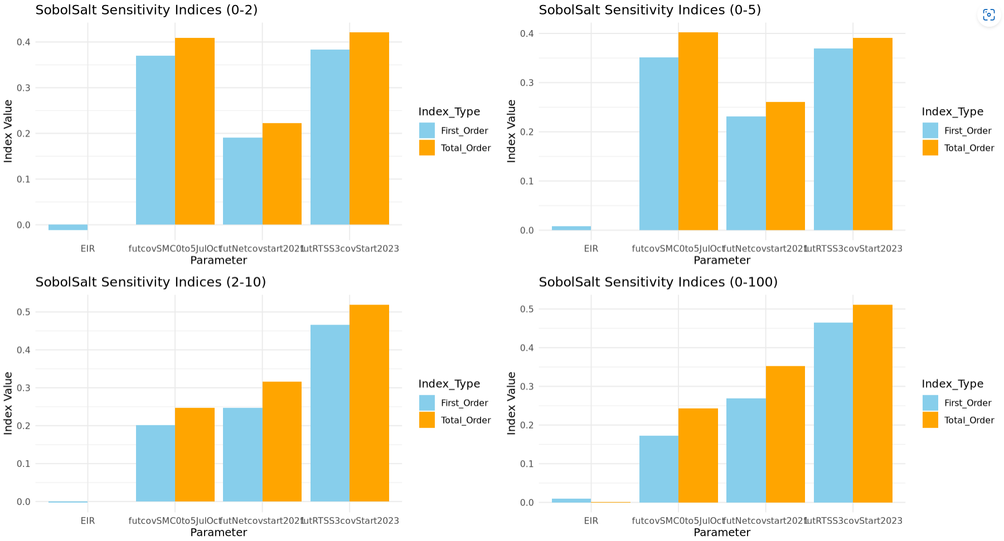

YCOL visuals
